

**Employee Attendance System**

**Outline:**

1. Functional Requirements
2. Non-Functional requirements
3. Technical Specifications
4. Diagrams

4.1 Use-case Diagram

4.2 Activity Diagram

4.3 Data flow diagram

4.4 ERD ( for database )

4.5 Component diagram

**I. Functional Requirements (What the system *will do*)**

* **A. Employee Management ( Manager module):**
* Manage will be able to:
  1. Add new employees
     + ID
     + Name
     + Department
     + Designation
     + Contact information
     + Job timing).
  2. Update employee information (All above).
  3. Deactivate/terminate employee accounts.
  4. Search employee records.
  5. Generate reports of employees.
* **B. Attendance Tracking:**
  1. Record employee clock-in/clock-out times and take picture at that moment.
  2. Automatic calculation of working hours.
  3. Support for different attendance types (present, absent, late, holiday, leave).
  4. Employee will be able to request and approve/reject attendance adjustments (e.g., missed clock-out).
  5. Real-time attendance dashboard for managers.
* **C. Leave Management:**
  1. Employee requests for different types of leave (sick leave, vacation, personal leave. **When on leave, provide leave reason. If sick, provide doctor document**).
  2. Leave approval/rejection (by manager/HR of Member company).
* **D. Reporting ( Manager module):**
  1. Generate attendance reports (monthly)
  2. Export reports in various formats (CSV, Excel, PDF).
* **E. User Roles and Permissions:**
  1. Different user roles (employee, manager, and administrator) will be available.
  2. Role-based access control to different features and data.
  3. Manager will have permissions of:
     + Add new employee
     + Update data of employee and his own profile.
     + Terminate employee and remove his/ her data.
  4. Employee will have permissions of:
     + Login
     + Mark his/ her attendance as:
       - Present
       - On Leave
       - Absent (Automatically save if not present marked )
     + View attendance.
     + Update his / her contact information.
  5. Manager will have all access of data of employees and manager to view it and update it.
  6. All users including employees, manager and admin will login by providing:
     + Email
     + Password

Initially all these email and passwords to managers will be provided by admin.

1. **Control panel:**

Owners of software will have a control panel in which after login, membership would be issued to the clients and they can use the system according to the package.

1. Control panel admin Will have following options on his/her dashboard:
2. Add Member
3. Update member
4. Delete member
5. View member
6. Update profile
7. Admin will provide following details to add new member/ company to use this system:
8. Member / Company Name
9. Email
10. Contact number
11. Number of employees (who will use this system)
12. Password

**Note:** This email and password will be provided by admin to company who want to use this system for his employees attendance.

1. Admin will be able to update company details and package.
2. Admin will be able to view members.
3. Admin will be able to delete members.

**2. Non-Functional requirements**

**A. Performance:**

1. Fast loading times.
2. Responsive user interface.

**B. Security:**

1. Secure user authentication and authorization.
2. Data encryption method use for passwords storing.

**3. Technical Specifications**

It will be a website based system using following technologies:

1. Frontend: HTML , CSS , JS
2. Backend : PHP
3. Hosting & domain : Will be purchased

**Diagrams**

**Use case diagram**

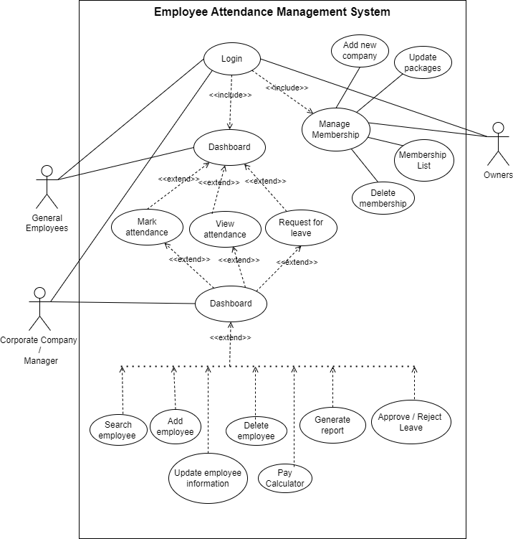

**Activity Diagram**

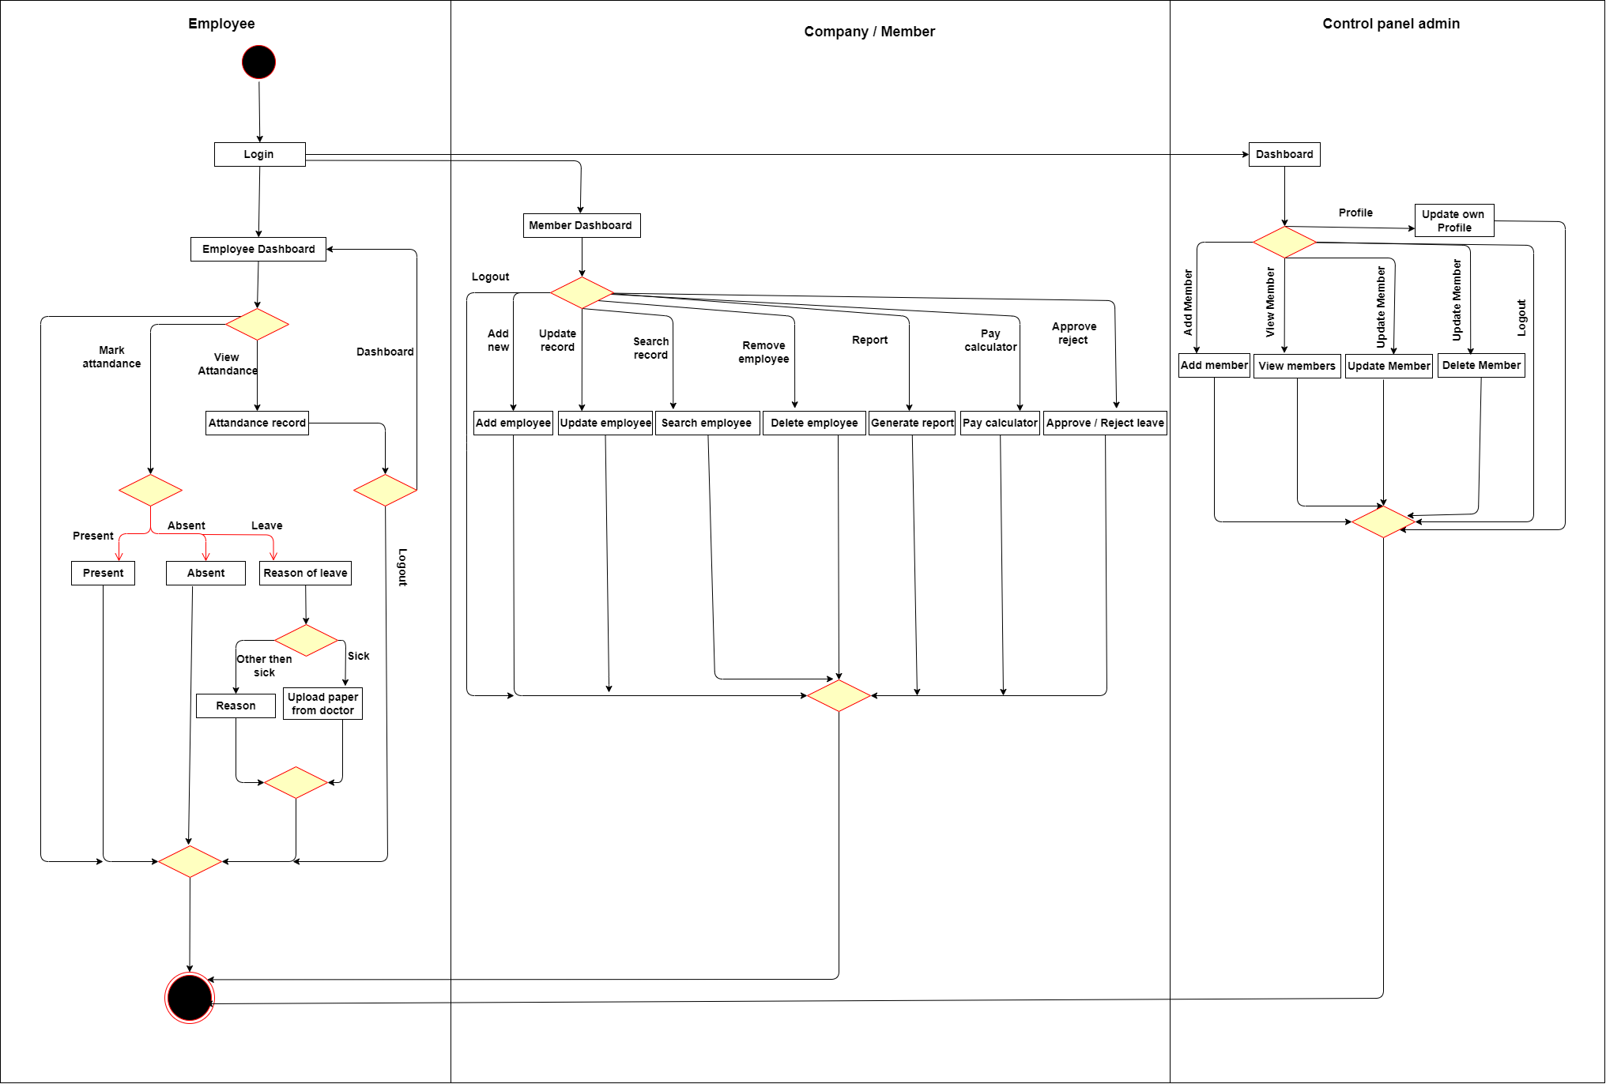

**Data flow diagram**

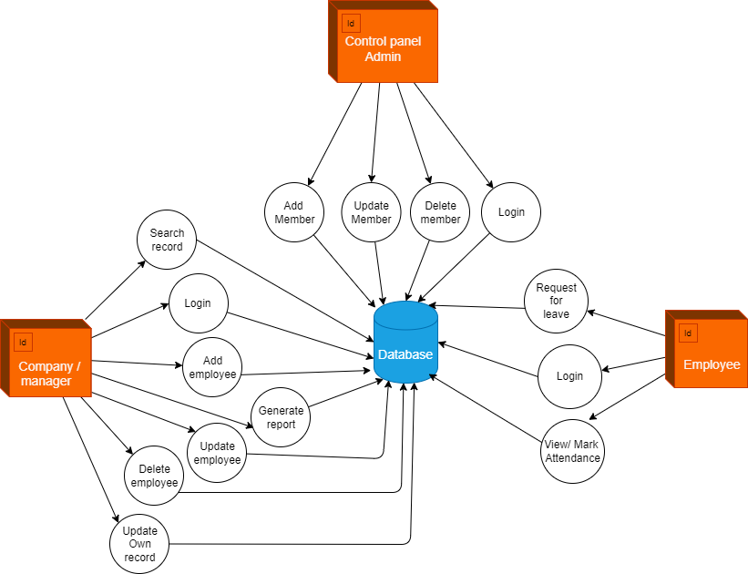

**ERD (Entity Relationship Model / Diagram)**

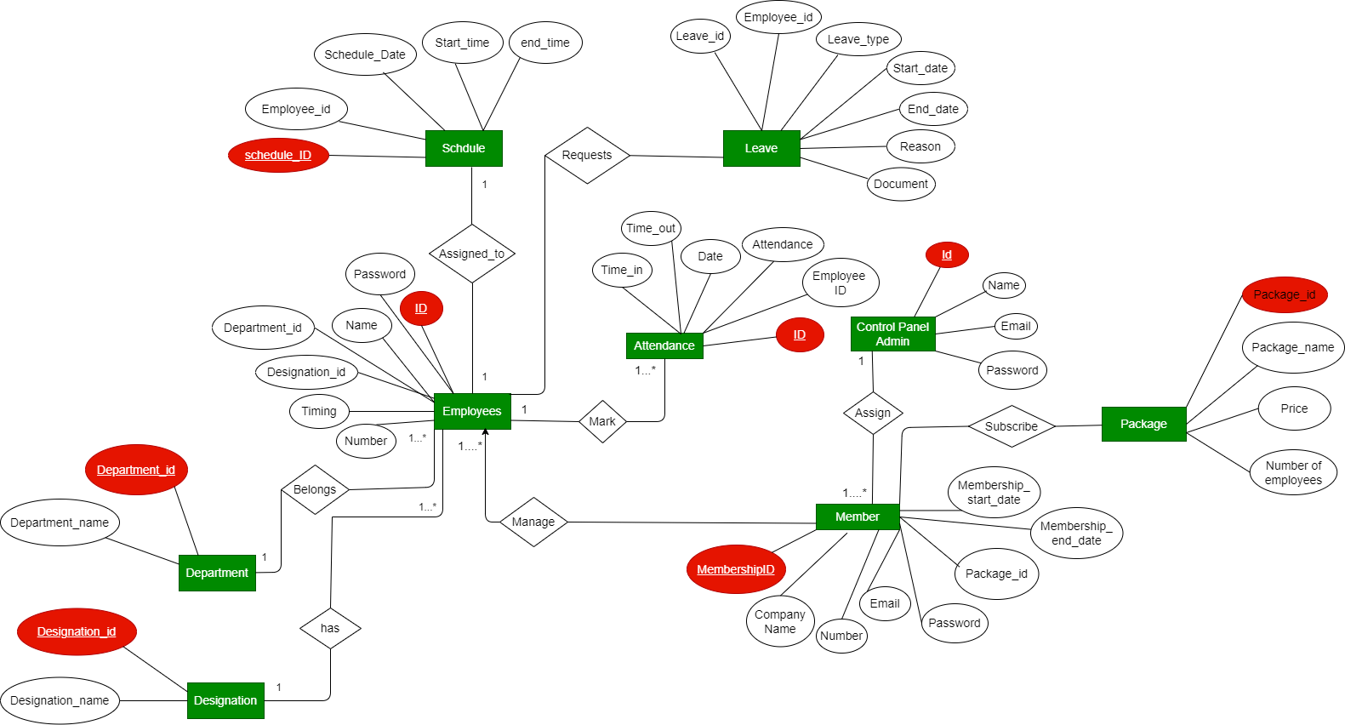

**Component diagram:**

